# Crude instructions for assessment solution

## Companies List

View existing Companies. Links for Add, Edit, Delete and Import new Companies.

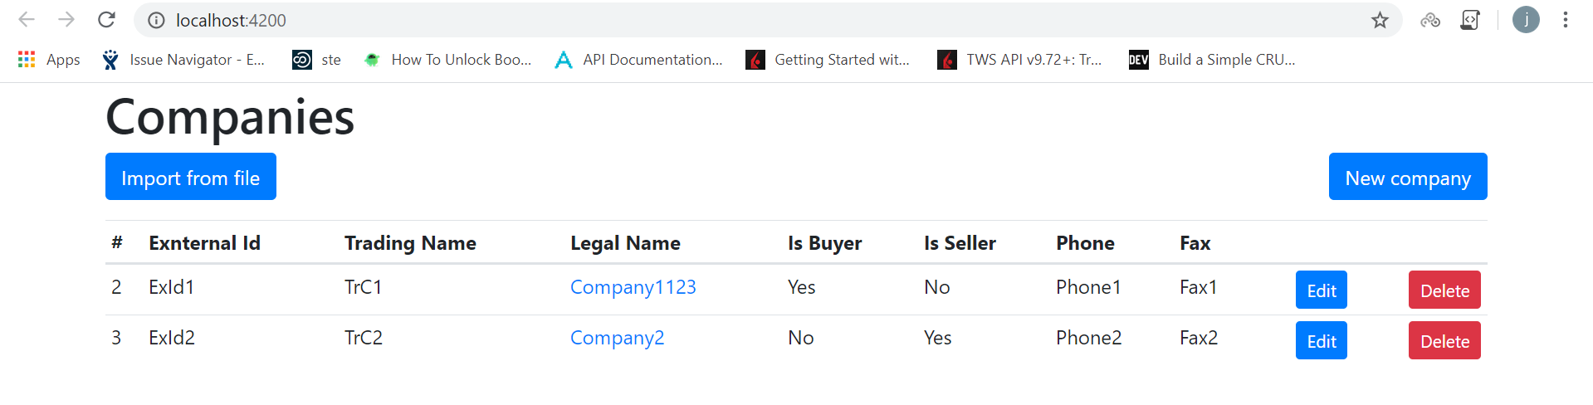

## Add new Company

1. Press New Company

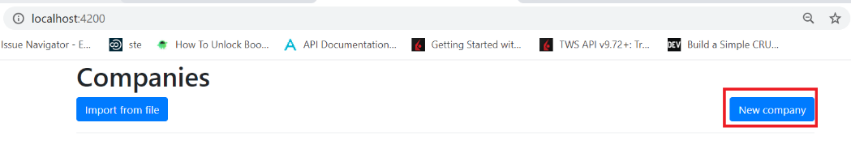

1. Fill data and press Save

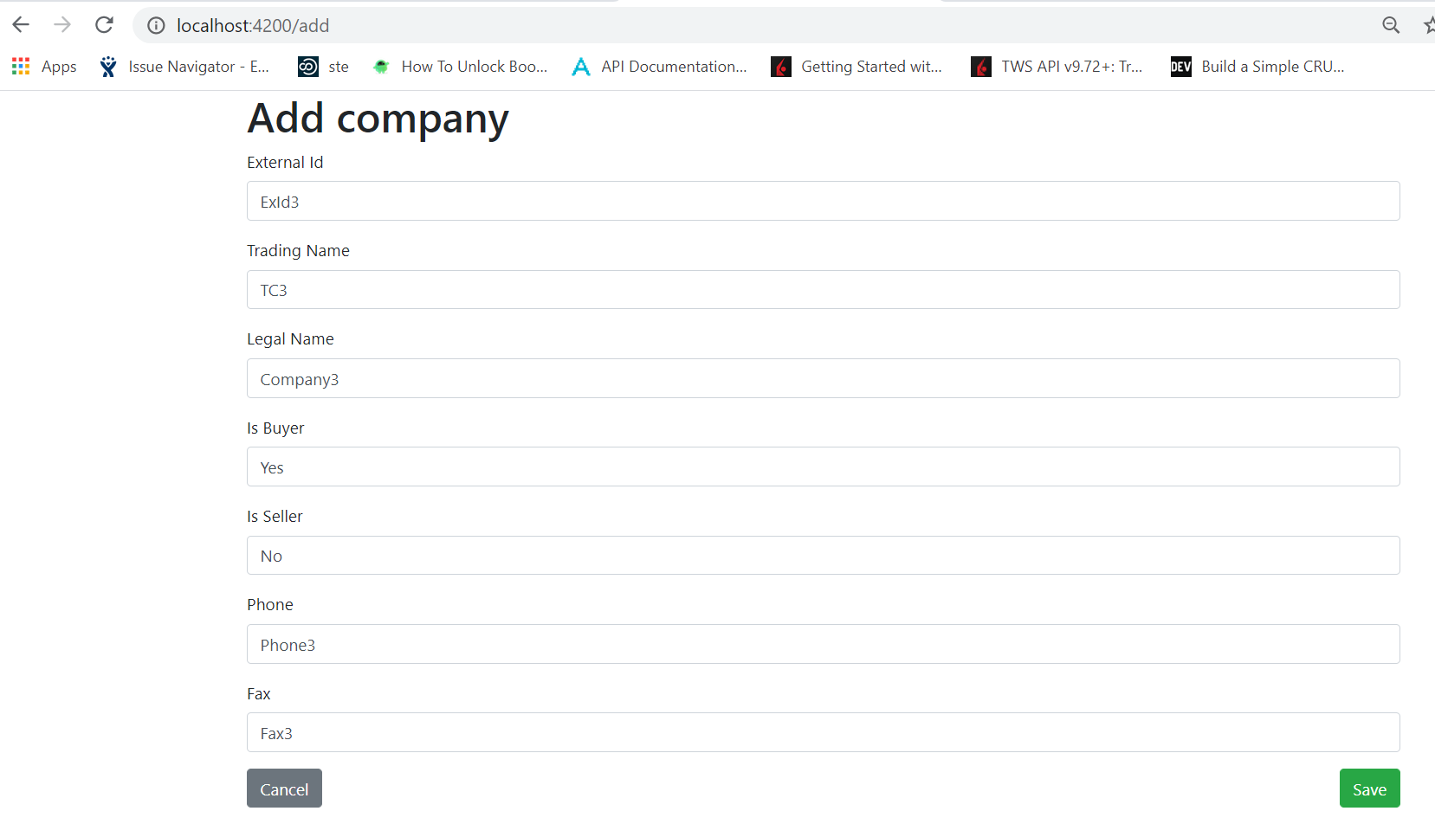

## Edit existing Company

1. Press Edit on one of Companies in list.

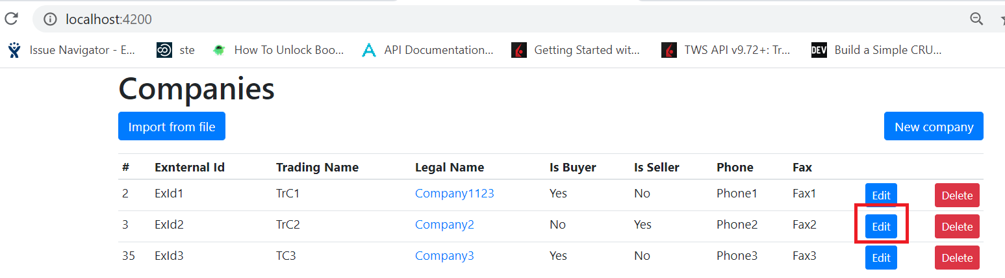

1. Edit information and press Save

## Delete existing Company

1. Press Delete on one of Companies in list

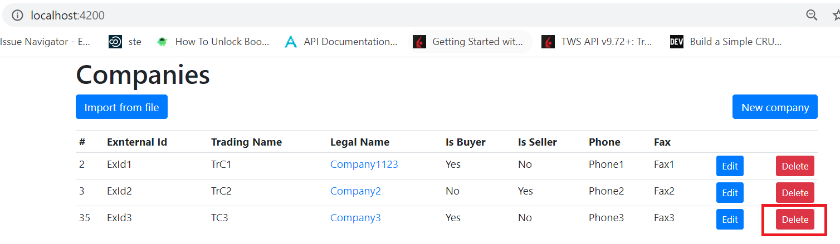

1. Confirm deletion

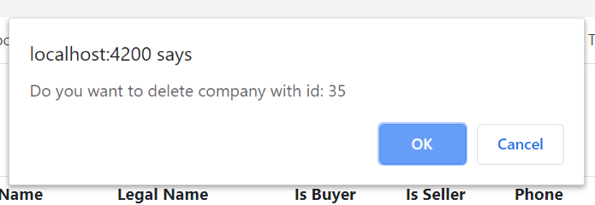

## Import companies from CSV file

1. Press “Import from file”

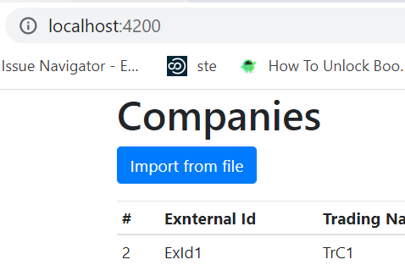

1. Choose CSV file

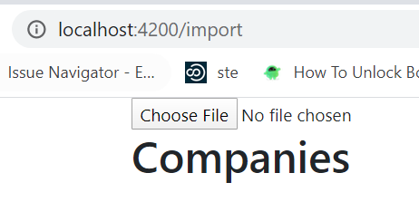

1. Edit data before importing by double clicking cell

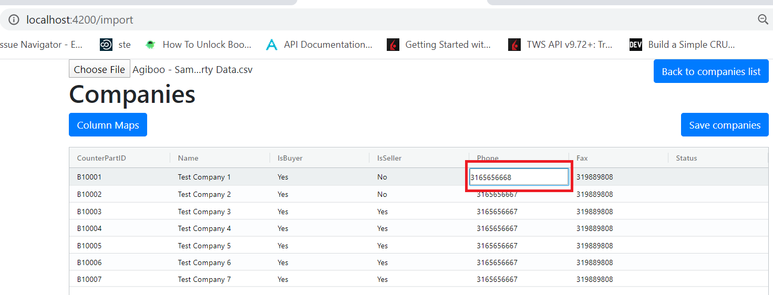

1. Check Column mapping by pressing “Column Maps”

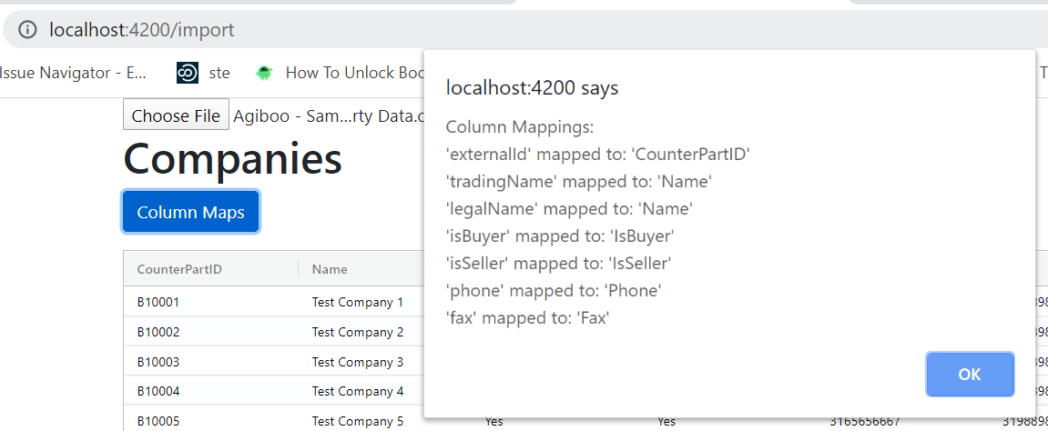

TBC (To be created) change of mappings.

1. Save companies

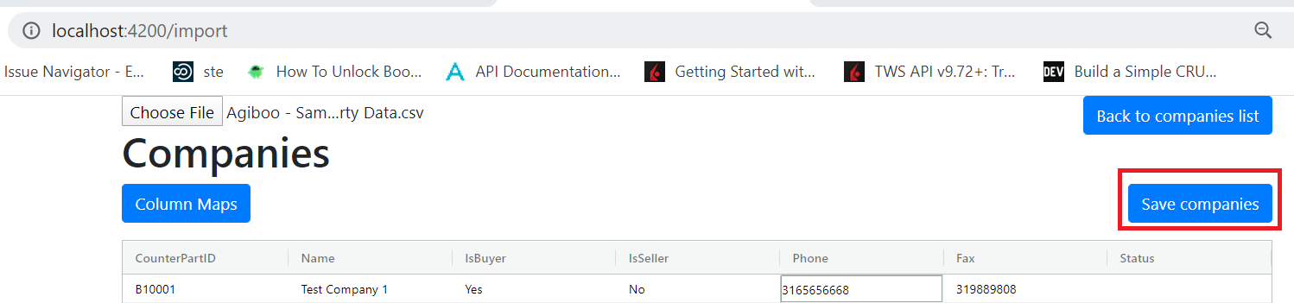

1. In case of errors, fix data or mappings and press “Retry to save errors”

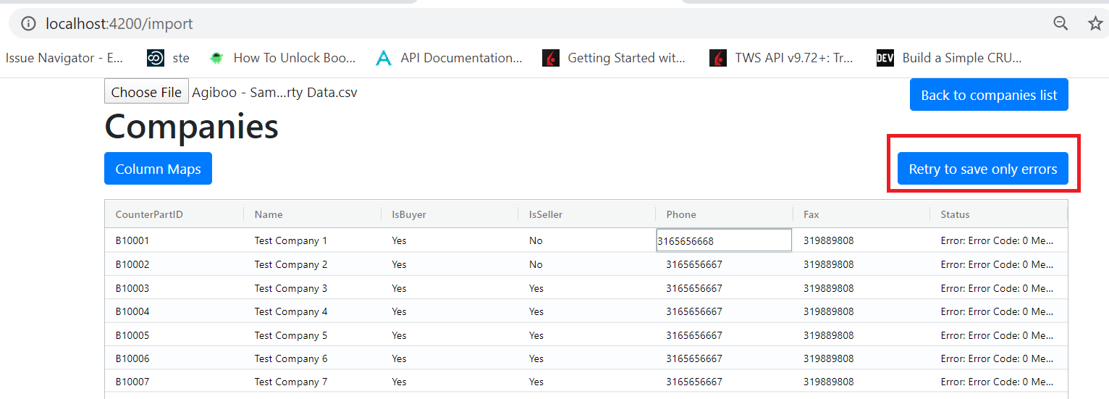

1. Check rows Status and move back to Companies list

